

  - Orca Pacific, Inc.– J882264

Functional Requirements Document (FRD)

Copyright© 2018, Oracle and/or its affiliates. All rights reserved.
Any reproduction or distribution of any part of this document without the prior written permission of Oracle + NetSuite is strictly prohibited.
The information included in this document is confidential and proprietary information of Oracle + NetSuite.
Version: March 3, 2022

Oracle + NetSuite
2955 Campus Drive, Suite 100
San Mateo, CA. 99403-2511

Project Information
Implementation Name | SS4C Customization
Customer Name (Number) | Orca Pacific, Inc.
Job Name (Number) | J882264
Document Owner | Aarti Joshi
Project Manager | Aarti Joshi
Lead Developer | Ilan Daniele

Document Version History
Rev | Date | Author(s) | Change Summary
1.0 | 10/06/2022 | Aarti Joshi | Initial Draft

Table of Contents
1 Business needs 4
2 Impacted areas/modules [Optional as output] 4
3 Acceptance criteria 5
4 Solution proposal 5
5 Prerequisites 6
6 Assumptions 6
7 Constraints and limitations 7
8 Risks 7

Business needs
- Orca Pacific Inc., based in the Seattle area, was established by Dick Kimura as a chemical pool and spa supply business. Now spanning two generations, we have also moved into the industrial water treatment side of chemicals. We manufacture our own line of chemicals which remains a proprietary enzyme blend for commercial accounts. Orca Pacific is also known for prompt and timely product delivery, and a 24/7 response to customer emergencies. This business is built on excellent customer service skills and product integrity. Orca pacific is looking for below customization in My account portal to provide better visibility of customer details

Feature 1: Create and implement a custom fuel surcharge extension on the checkout page.
Feature 2: Create up to one (1) page view on the MyAccount section for the following:
- Display a list of text-only custom fields for the user to fill out.
- Allow the user to upload a single PDF file to the customer record.
- Link the new page view to the MyAccount navigation menu.
Feature 3: Create up to one (1) page view on the MyAccount section for the following:
- Display the results of a saved search listing work orders assigned to the customerDisplay custom form to allow users to register their purchased products.

Impacted areas/modules [Optional as output]

Acceptance criteria
- It should display the Orca Delivery method when zip code is existed in record.
- It should not display the Orca Delivery method when zip code is not existed in record and show warning message.
- Correct shipping cost from custom record will be applied in checkout based on Zip code entered in shipping address.
- Customer should be able to select other delivery method if Orca delivery method is not available for entered zip code.
- New Warranty claim section should be displayed.
- All the required field should be displayed in Warranty claim section.
- Customer should be able to enter all the required field and submit the claims.
- Warranty claims record information should get saved in Customer record in NetSuite.

Solution proposal

Feature 1: Create and implement a custom fuel surcharge extension on the checkout page
- Custom Record with shipping cost
  - New custom record “Orca Delivery Shipping Cost” is already created with zip codes and their shipping cost.
- Calculate the shipping cost based on custom record when “Orca Delivery” shipping method is selected in checkout.
  - Shipping cost will be displayed based on zip code entered in shipping address in checkout.
  - Shipping cost will be displayed as separate line.
- Orca Delivering shipping method should not be displayed if zip code is not existed in custom record i.e., “Orca Delivery Shipping Cost”
  - If orca delivery is not available, then show Information message – Orca Team to provide message.
Feature 2: Create new section in My account page to fill the warranty form.

- New Section “Warranty Claims” will be created next to Case Section.
- Below field should be displayed in Warranty claim section and all fields are required.
    - Customer Name
      - Field Type -free text
      - No char limits
    - Phone Number
      - Field Type -free text
      - Validation – Customer should be able to enter only numeric values (validatePhone in Utils)
    - Email
      - Field Type -free text
      - Validation – Email format must be valid else show warning message. (name@email.com) (Regular expression that I will create)
    - Billing Address
      - Field Type -free text (whole address will be entered)
      - No char limits
    - Shipping Address
      - Field Type -free text (whole address will be entered)
      - No char limits
    - Manufacturer Case Number
      - Field Type -free text
      - No char limits
    - Model Number
      - Field Type -free text
      - No char limits
    - Serial Number
      - Field Type -free text
      - No char limits
    - Date of Purchase/Where was it purchased from? Date picker
      - Field Type -Date Picker
      - Validation: It should not be future date. (Limit the date picker, limit selection, dates more than today dehabilitated)
    - Who Installed it
      - Field Type -free text
      - No char limits
    - Description of Issue
      - Field Type -free text
      - No char limits
    - Photos of equipment in question
      - Customer should be allowed to upload at least 3 images
      - File type – jpeg, png
      - We need a fixed amount of images for this case. How much? There would be 3 custom fields if it’s 3 images, and we press and add the images individually. Otherwise will be too complex to make it have quantity of photos dinamycally.
      - We will use 3 custom fields of input type file. OK
      - Also on code we need to know in which folder we paste the content. Is it a specifical folder for each customer independently or a single folder for all? YES, single folder is easier
    - Orca Pacific Team will be responsible to delete the files in 30 days from file cabinet to avoid space issue
    - Submit button.

- Above entered information should be saved in Customer Record under new tab.
  - Create a custom record of type “warranty” that will be added to customer record.
  - Nice to have

    - If possible, create a subtab next to case to save warranty information. (With the configuration done for last bullet, will be added already).
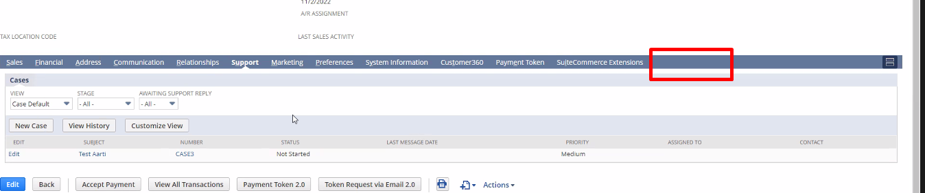

    - If possible, have the status field in form. What is status? What do you refer to?
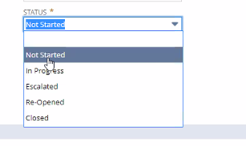
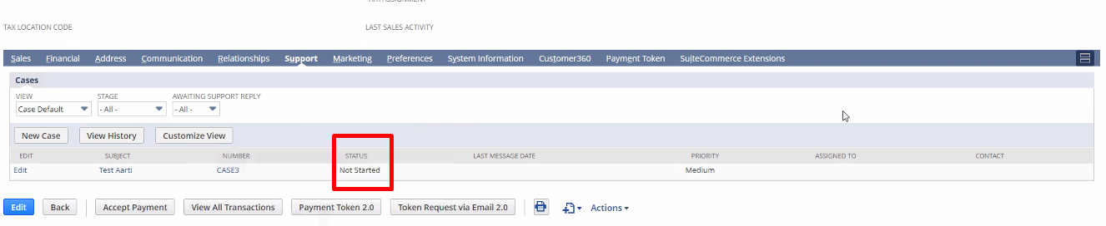

More questions:
- Final user, as client, if I entered a warranty, there should be a page where I can see my warrantied filled, where is that? Or we just forget about that? This is something complex to add, we forget about it.
Respondidas en documento “requirements”

Prerequisites
- Custom Record with zip code and their shipping cost must be created in NetSuite.

Assumption

- Orca Pacific Team will be responsible to delete the image files in every 30 days from file cabinet to avoid space issue.
- It would allow user to submit the warranty claims and it would not show the list of claims in My account.

Constraints and limitations

Risks

Oracle + NetSuite Professional Services and Customer are in agreement that the information documented above is accurate and representative of the customer’s business needs. This document will act as the basis for all subsequent implementation activities.
Document delivery date: MM/DD/YYYY

